A000-Asia-Japan-Gunma Prefecture-Azuma-machi-Jomon-Late Stage-Figurine-ハート型土偶-Heart-shaped-1000-300 BCE

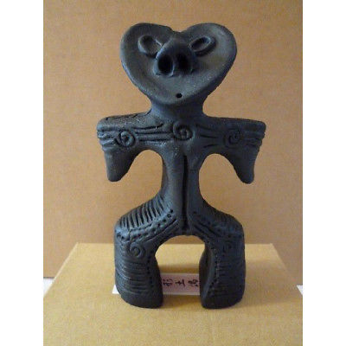

Fig. 1. Japan-Gunma Prefecture- Azuma-machi-Jomon, Late Stage-Figurine-ハート型土偶-Heart-shaped-1000-300 BCE

This is just a placeholder image until the actual artifact is photographed.

Case no.: 5

Accession Number:

Formal Label: Japan-Gunma Prefecture- Azuma-machi-Jomon, Late Stage-Figurine-ハート型土偶-Heart-shaped-1000-300 BCE

**Display Description:**

The markings on the surface of this Jomon figurines have been theobject of much speculation. In the 1870s, the Japanese government banned body modification among the Ainu, a small indigenous group who were once renowned for intricate face and arm tattoos. Philippe Dallais of the Museum of Ethnography in Neuchatel, Switzerland, believes they were the last practitioners of a tradition that stretched back thousands of years to the Jōmon people. Hunter-gatherers who eventually became sedentary, the Jōmon developed a complex culture that lasted from 12,000 to 300 B.C.

**LC Classification:** GN855.J2

Date or Time Horizon: 1000-300 BCE

Geographical Area: Azuma-machi, Gunma Prefecture, Gohara ruins.

**Map:**

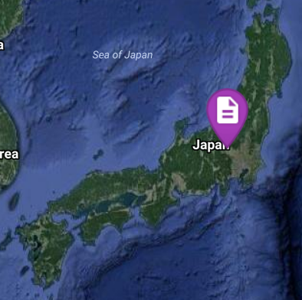

After http://latitude.to/articles-by-country/jp/japan/7895/gunma-prefecture

**GPS coordinates: 36°21'59.99" N 139°06'60.00" E**

Cultural Affiliation: Jomon

Medium: clay

Dimensions:

Weight:

Condition:original

Provenance:

**Discussion:** Archaeologists excavating Jōmon houses often unearth humanoid earthenware figurines known as Dogu that sport engravings on their faces and bodies. “I believe these marks in many cases represent tattoos,” says Dallais. “You often find them on arms and around the mouth and eyebrows, just like the tattoos of the Ainu.” No obvious tattooing tools have been found at Jōmon sites, but Dallais says stone tools could have been used to make them. “You have obsidian everywhere in Japan, and it’s possible to take a piece and quickly make small, neat incisions for tattooing.

**References:**

Aikens, M. and Higuchi, T. 1982, *Prehistory of Japan*, Academic Press, New York.

Akazawa, T. and Aikens, M. (eds.). 1986. *Prehistoric Hunter-Gatherers in Japan*. Tokyo: University of Tokyo.

Barnes, G. 1993. *China, Korea and Japan: The rise of civilization in East Asia*, Thames and Hudson, New York.

Bleed, P. 1976. Origins of the Jomon technical tradition, *Asian Perspectives*, **19**, 107-115.

Habu, J. 1996. Jomon sedentism and intersite variability: collectors of the Early Jomon Moroiso phase in Japan, *Arctic Anthropology*, **33**, 38-49.

Habu, J. and Hall, M. E. 1999. Jomon pottery production in central Japan*, Asian Perspectives*, **38**, 125-145.

Imamura, K. 1996, *Prehistoric Japan.* London:UCL Press.

Kidder, J. E. 1968. *Prehistoric Japanese Arts: Jomon Pottery*. Tokyo: Kodansha.

Kidder, J. E. 1993, The earliest societies in Japan, in (ed. D. Brown), *The Cambridge History of Japan, Volume 1: Ancient Japan*, Cambridge University Press, Cambridge.

Kobayashi, T., 1992. Regional organization in the Jomon period, *Arctic Anthropology*, **29**, 82-95.

Kobayashi, T., 1998, Hunterer-gatherer subsistance in Jomon Japan, *Memoir of the Museum of Archaeology, Kokugakuin University,* **14,** 3-18.

Koyama, S. and Thomas, D. H. 1981. *Affluent Foragers,* Senri Ethnological Studies, **2**.

Osawa, M., Kasuya, H., and Sakakibara, Y. 1977. Trace element abundances in stone artefacts and related materials from Japan by neutron activation analysis, *Journal of Radioanalytical Chemistry,* **39**, 137-152.

Pearson, R. 1990. Jomon ceramics: The creative expression of affluent foragers (10,500-300 B.C.), in  (ed. E. Weeder), *The rise of a great tradition: Japanese archaeological ceramics from the Jomon through Heian periods (10,500 B.C. to A. D. 1185)*, 15-27. New York: Japan Society.

Pearson, R. 1992 The Nature of Japanese archaeology, *Asian Perspectives,* **31**, 115-162